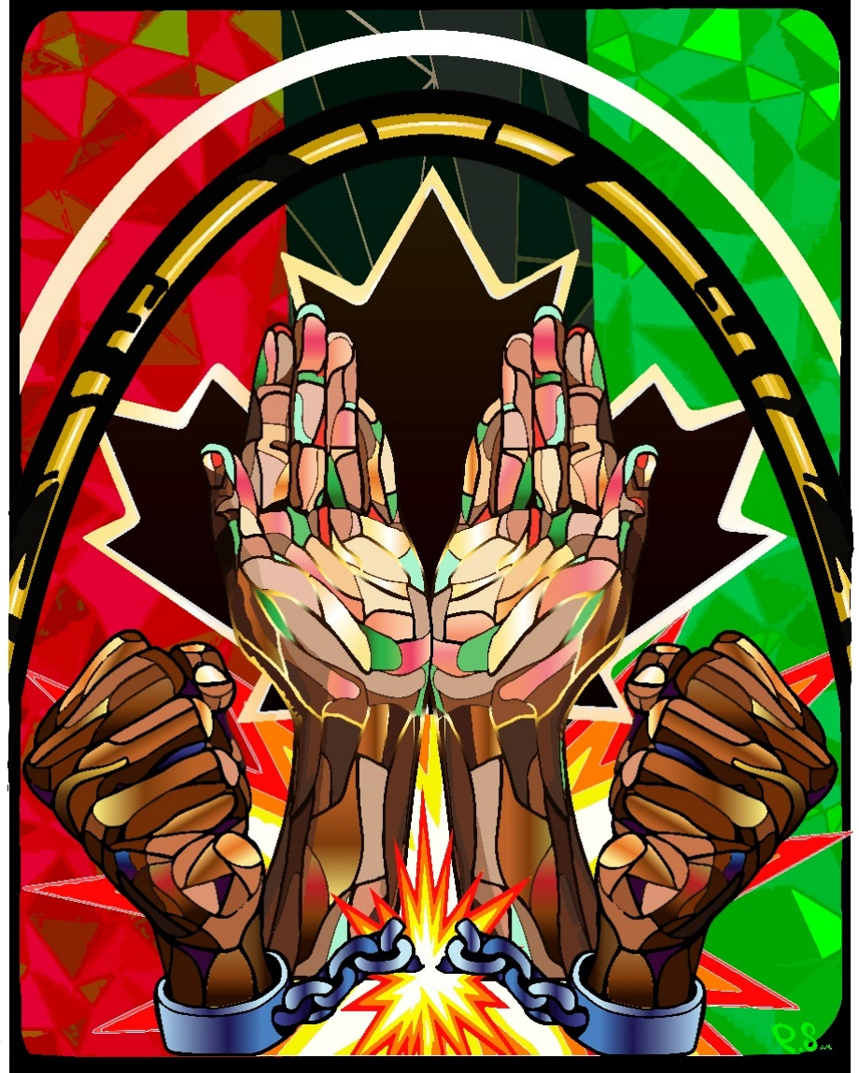
What is Emancipation Month/Day?
Canadians are not always aware that Black People were once enslaved on the land that is now Canada. Those who fought enslavement were pivotal in shaping our society to be as diverse as it is today.
Emancipation Month recognizes the struggle for human rights and the rich contributions made by Peoples of African descent. Recognizing Emancipation Month in August acknowledges a horrible period in our history and our ongoing commitment to eliminate discrimination in all forms.
On March 24th, 2021, members of Canadian parliament unanimously voted to designate August 1st as Emancipation Day in Canada. Emancipation Day marks the day the Slavery Abolition Act came into effect throughout the British Empire in 1834. Thus, marking an end of more than 250 years of chattel slavery for millions of African people and their descendants in Canada and around the world.
Artwork by Phillip A. Saunders: a multidisciplinary artist and arts educator. His work attempts to bond the past and present through figurative expressions nuanced in West African igbo culture. Find out more about Phillip https://www.phillipasaunders.com/.

Why Recognize Emancipation Month/Day?
- Emancipation Day is an opportunity to learn more about the history of African people and communities, and to continue to address and eradicate systemic anti-Black racism.
- The month will also allow us, as a community, to reflect and acknowledge our shared history of the enslavement of people of African descent in Canada.
- Celebrating Emancipation Day will also provide us with an opportunity to maintain ongoing meaningful dialogue around race relations and inclusive communities.
- Most importantly, the day encourages us to educate ourselves and act.
Learn more about Emancipation
- Government of Canda: https://www.canada.ca/en/canadian-heritage/campaigns/emancipation-day.html
- Bruce County Public Library: Emancipation in Canada | Bruce County Public Library
- Emancipation Festival: Emancipation Reads — Emancipation Festival

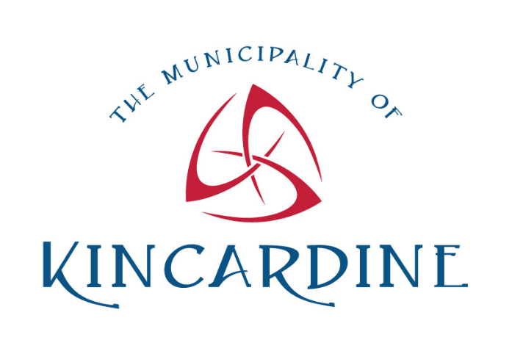
Events
Municipality of Kincardine Flag Raising
To launch Emancipation Month, the Municipality is hosting a flag-raising ceremony of the Black Liberation flag on August 1st, 2025 at the following location:
Bruce County Public Library, 11:00 a.m.
The public are invited to join Council members and staff to show the ongoing commitment to eliminate anti Black racism and discrimination of all forms. The flag is a reminder that despite the progress made, there is still a long road to equity.
About the Black Liberation Flag
The Black Liberation Flag is a tri-color flag consisting of three equal horizontal bands of (from top down) red, black and green.
The flag was designed by Marcus Garvey in 1920 in response to racism and has become a powerful symbol worldwide, representing people of the African Diaspora, Black Freedom, and Black Unity.
The red, black, and green of the flag each have a specific meaning.
- Red: the blood that unites all people of Black African ancestry and shed for liberation.
- Black: black people whose existence as a nation, though not a nation-state, is affirmed by the flag.
- Green: the abundant natural wealth of Africa.
The flag is a reminder that despite the progress made, there is still a long road to equity.
Source: On Flag Day, Remembering The Red, Black And Green : Code Switch : NPR
Owen Sound Emancipation Festival: www.emancipation.ca
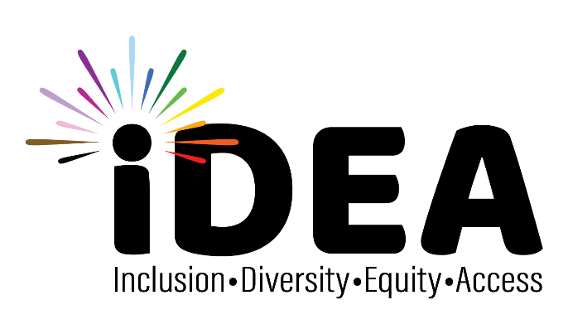
The Emancipation Festival located in Grey Bruce and Simcoe Counties has the distinction of being the longest continuously running Emancipation Picnic/Festival in North America. The Emancipation Festival board of directors works in tandem with numerous community and cultural organizations to recognize Underground Railroad destination points (Owen Sound being the most northerly terminus of the Underground Railroad) and individuals descendent from the slaves who traveled its path.

For more information:
The Municipality of Kincardine https://www.kincardine.ca/live-here/inclusion-diversity-equity-and-access-idea/
Or contact Mackenzie Clarke: 519 396-3468
mclarke@kincardine.ca

